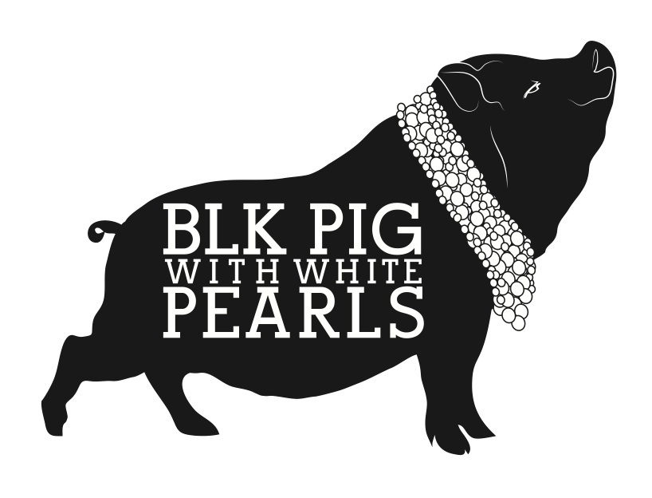

£50 Sharing Tapas For 2 Menu

Please choose either bread with alioli & olives or a sharing dessert
Why not add a bottle of our homemade sangria for that real Spanish vibe for £15

Starter

Sourdough with Aloili & Manzanilla Olives

Sharing Tapas

Veggie Paella

Spicy lentil meatballs in a tomato sauce

Croquettes del dia

Padron peppers (vg)

Piquillo peppers stuffed with mushrooms topped with a creamy Piquillo sauce

Patatas bravas Fried potatoes with a spicy sauce & garlic alioli

Please ask for the specials of the day and we can change any of them for something else.

Sides (not included in the price)
Spinach with garlic £4
Roasted Almonds £4

Desserts

Churros with a chocolate sauce

Please let us know if you have any dietary requirements or allergies

