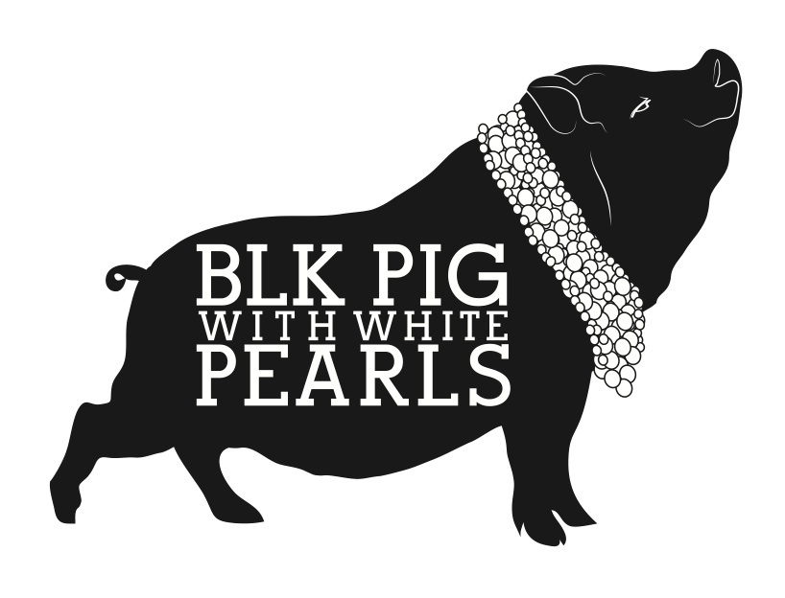

ALL COCKTAILS £8
MONDAY – THURSDAY 6PM – 7.30PM £6

THE SEVILLE MARTINI
gin, triple sec, lemon juice, Seville marmalade

ALMOND PX SOUR
Pedro Ximenez sherry, Ameretto, lemon juice, egg white

NEGRONI
Gin, Campari, sweet vermouth

THE OLE FASHIONED
Pikesville rye whiskey, home made alahmbra beer reduction, Angostura

THE SPANISH SIDE CAR
Romato brandy, Cuarenta y Tres, lemon juice

SANGRIA
Tempranillo red wine, 43, brandy, fruit juice, lemonade, fresh fruit

ESPRESSO MARTINI
Vodka, café liquor, Pedro Ximenez sherry, espresso coffee

MOJITO
Bacardi blanco rum, soda, mint, fresh lime, sugar

MARGARITA
Tequila, Cointreau, fresh lime

