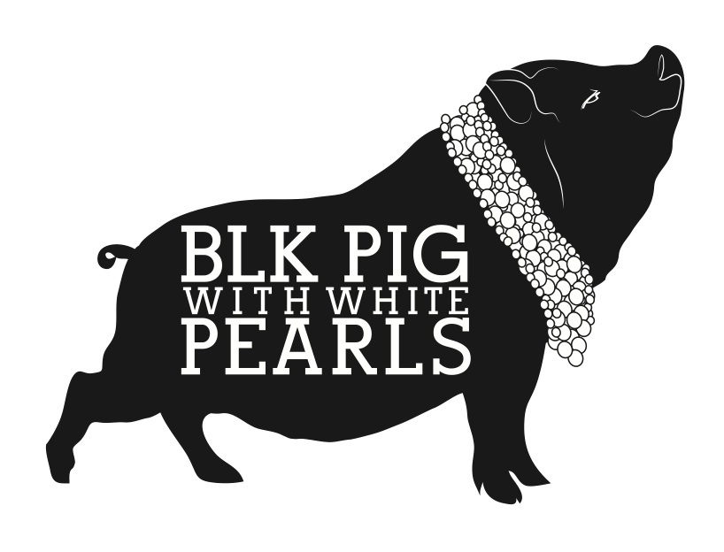

£50 Sharing Tapas For 2 Menu

Please choose either bread with alioli & olives or a sharing dessert
Why not add a bottle of our homemade sangria for that real Spanish vibe for £15

Starter

Sourdough with Aloili & Manzanilla Olives

Sharing Tapas

Arroz negro black Sqiud ink rice with calamari

Spicy Chorizo in wine sauce

Croquettes del dia

Padron peppers (vg)

Piquillo peppers stuffed with prawns Topped with a creamy Piquillo sauce

Patatas bravas Fried potatoes with a spicy sauce & garlic alioli

Please let us know if there’s anything you need to change

Sides (not included in the price)
Spinach with garlic £4 Jamon Iberico £9
Roasted Almonds £4 Cured Beef Cecina £9

Desserts

Almond tart with lemon cream

Dulce de leche (caramel cream layered with coffee dipped biscuits and a toffee caramel sauce

Selection of Spanish Cheeses with quince and crackers (£4 supplement)

Please let us know if you have any dietary requirements or allergies

